**Create To Do List : POST URL :** [**http://localhost:8081/todoList/webresources/myToDoList**](http://localhost:8081/todoList/webresources/myToDoList)

**Payload :**

{

    "listName": "MAVEN",

    "description" : "AU MAVEN Assignment"

}

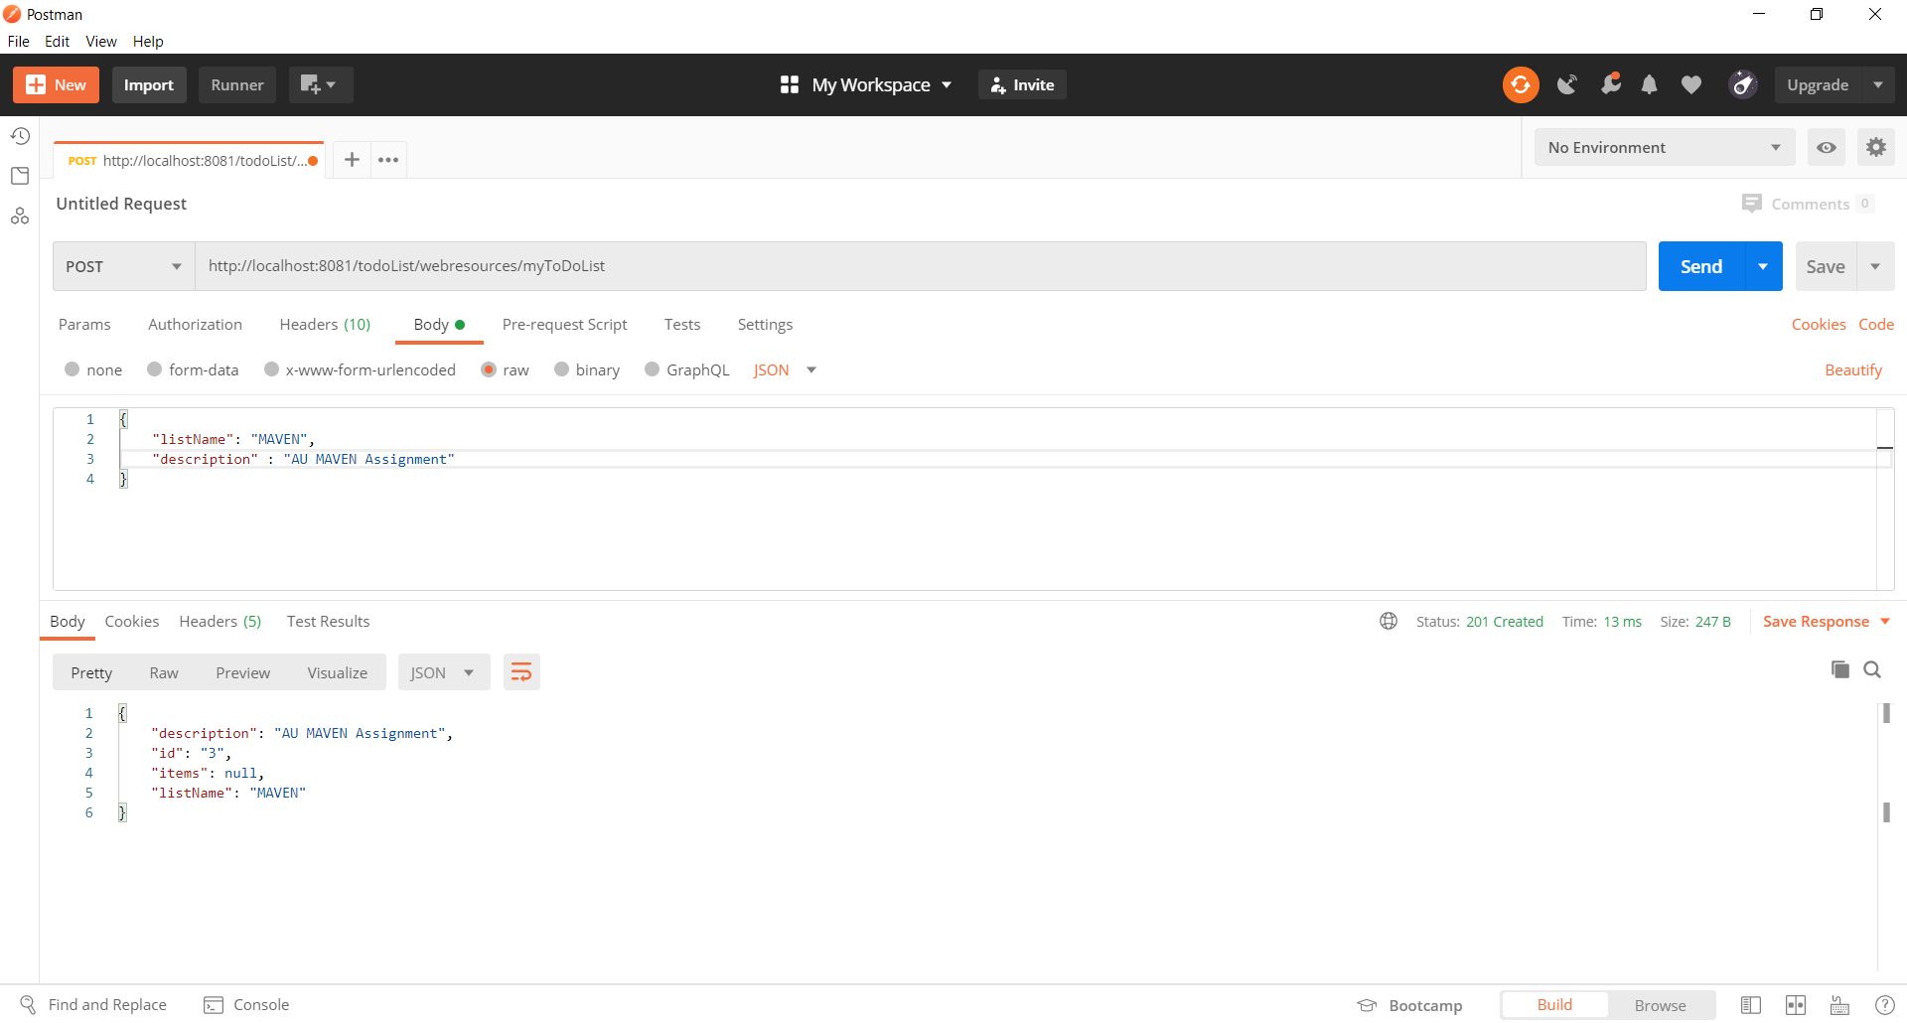

**Delete To Do List : DELETE URL http://localhost:8081/todoList/webresources/myToDoList/3**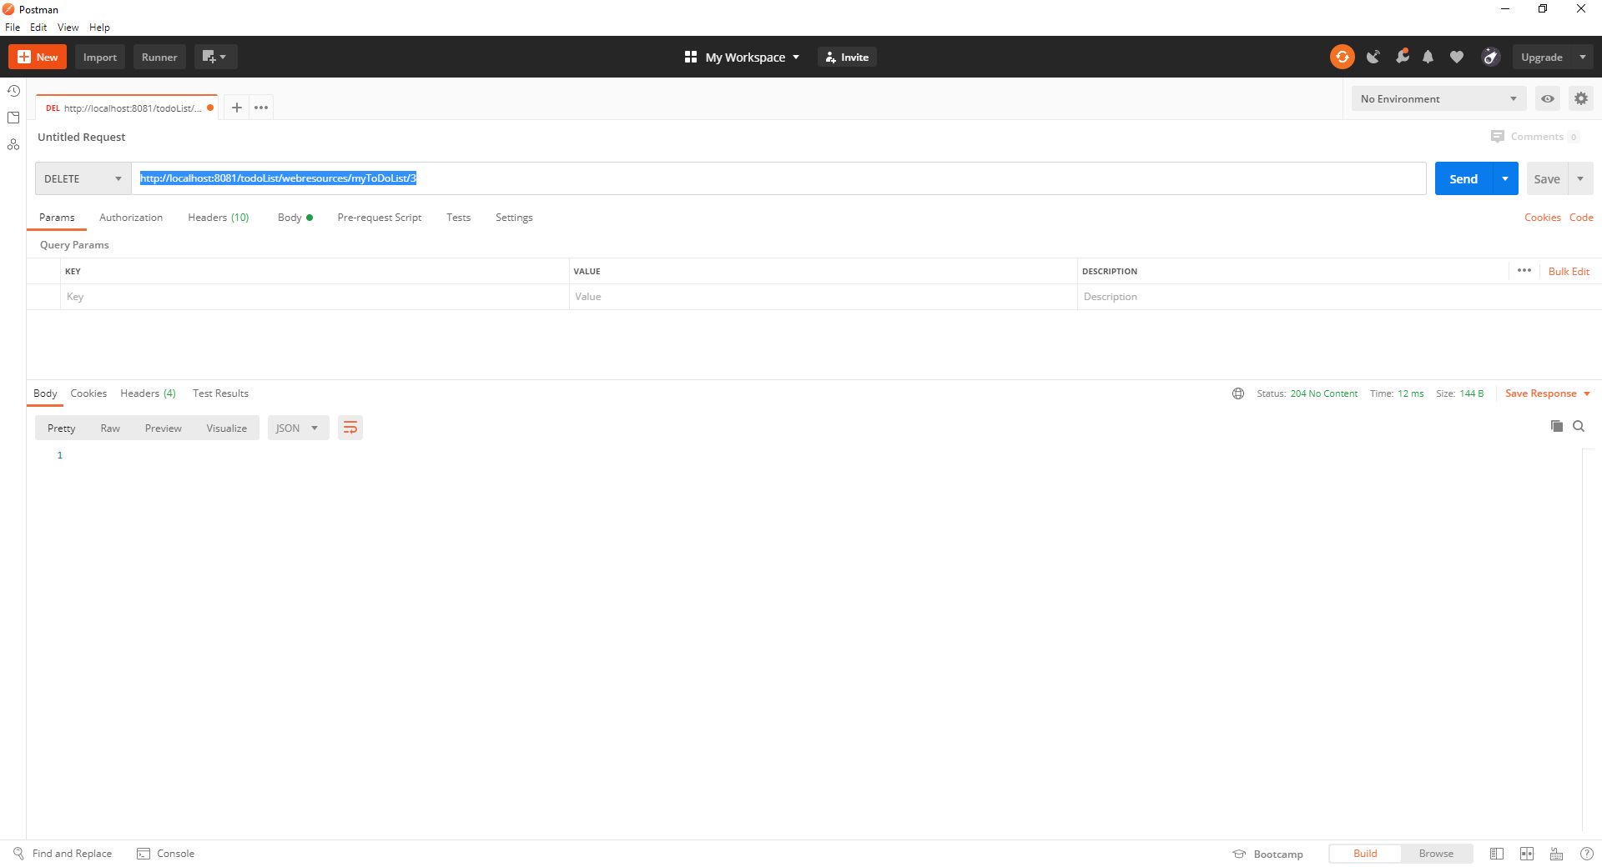

**Fetch ALL To Do List : GET URL :** [**http://localhost:8081/todoList/webresources/myToDoList**](http://localhost:8081/todoList/webresources/myToDoList)

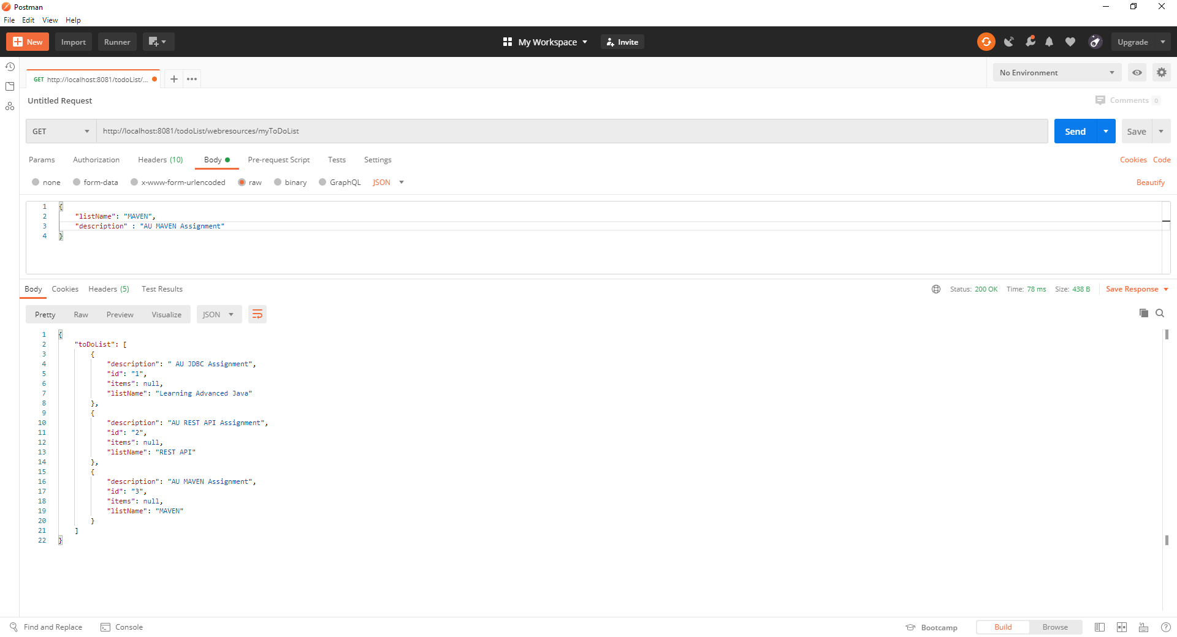

**Fetch To Do List with specific Id : GET URL :** [**http://localhost:8081/todoList/webresources/myToDoList**](http://localhost:8081/todoList/webresources/myToDoList)/1

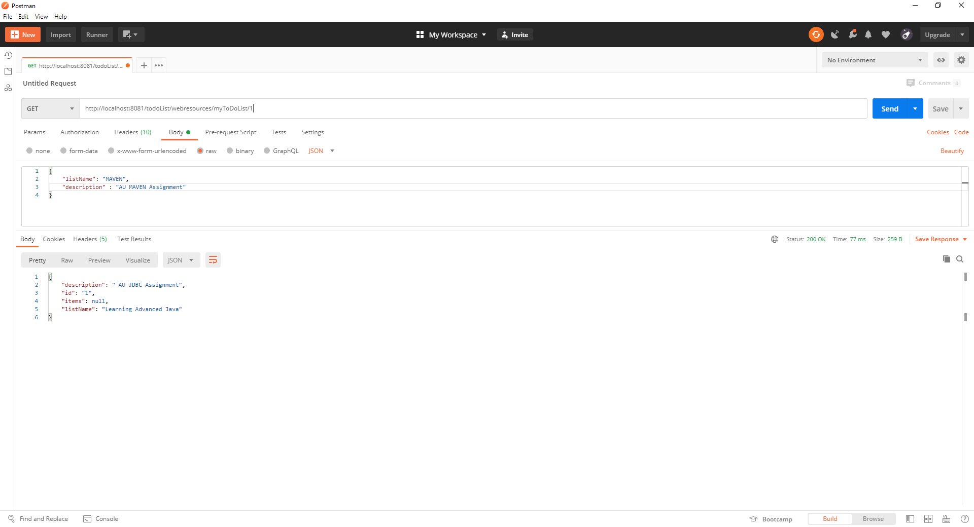

**Update To Do List Description: PUT URL : http://localhost:8081/todoList/webresources/myToDoList/3**

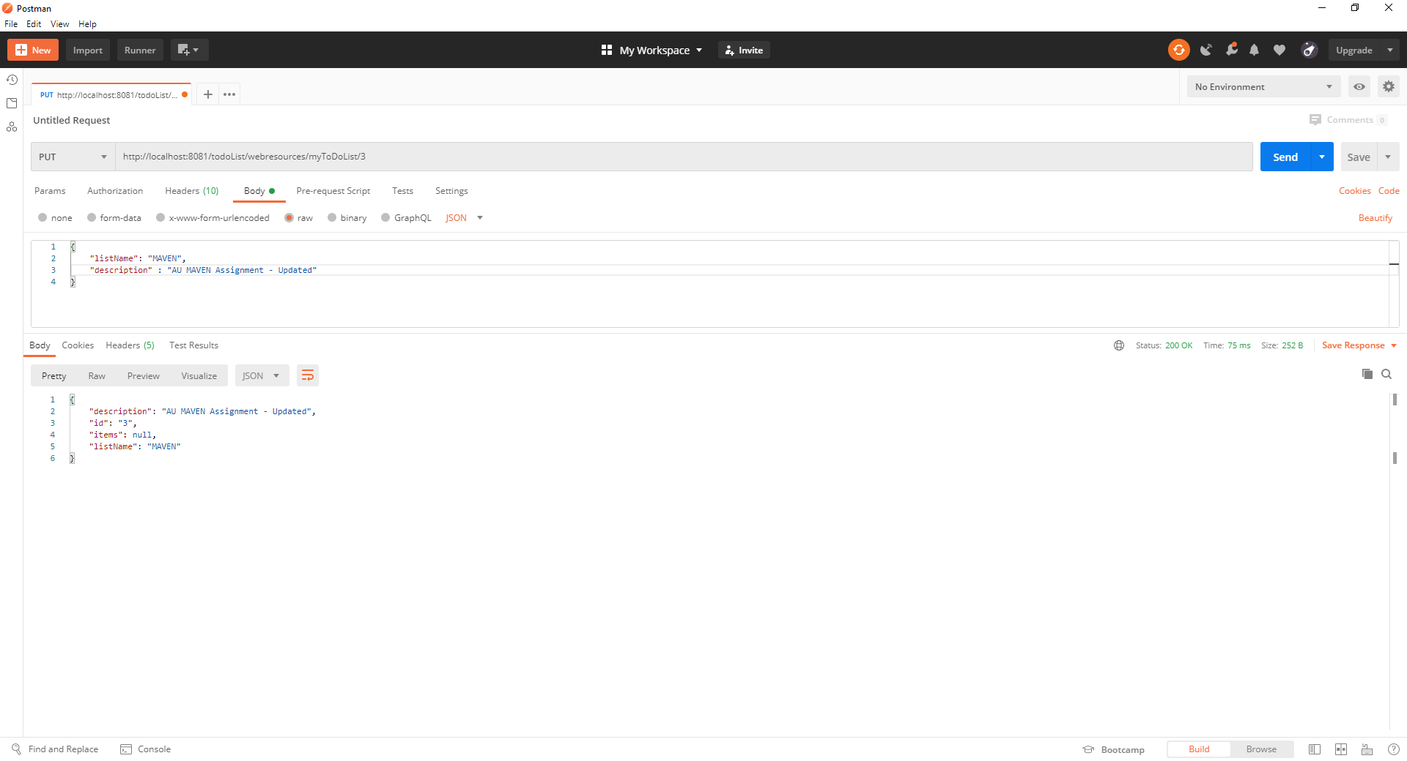

**Creating Items for to do list : POST URL http://localhost:8081/todoList/webresources/myToDoList/1/items**

{

    "itemName": "Create TODO List",

    "itemDescription" : " First REST Assignment",

    "isCompleted" : true

}

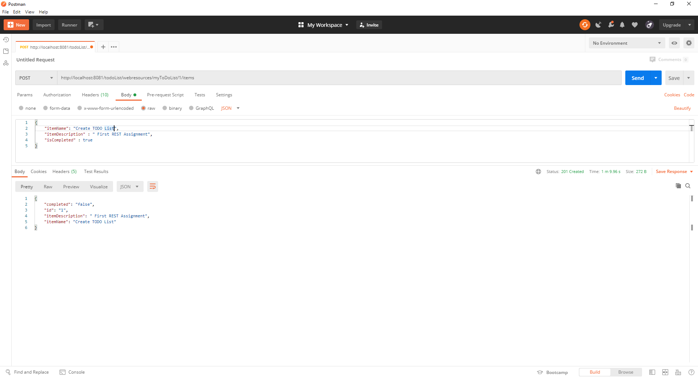

**Get All the Items for a TO Do List : GET URL :** **http://localhost:8081/todoList/webresources/myToDoList/1/items**

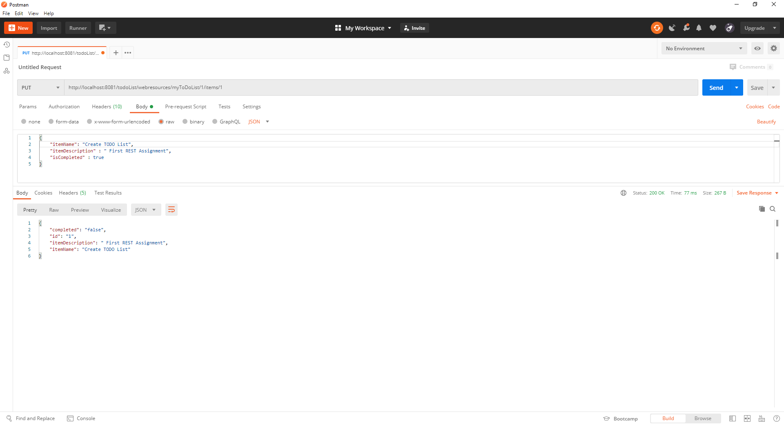

**Update the item completed status from “false” to “true” : PUT URL :http://localhost:8081/todoList/webresources/myToDoList/1/items/1**



**Get ITEM with ItemId : GET URL :**

**http://localhost:8081/todoList/webresources/myToDoList/1/items/1**



**Delete Item from To do list : Delete URL http://localhost:8081/todoList/webresources/myToDoList/1/items/1**

